Carly Telford - Goalkeeper | Karen Bardsley - Goalkeeper
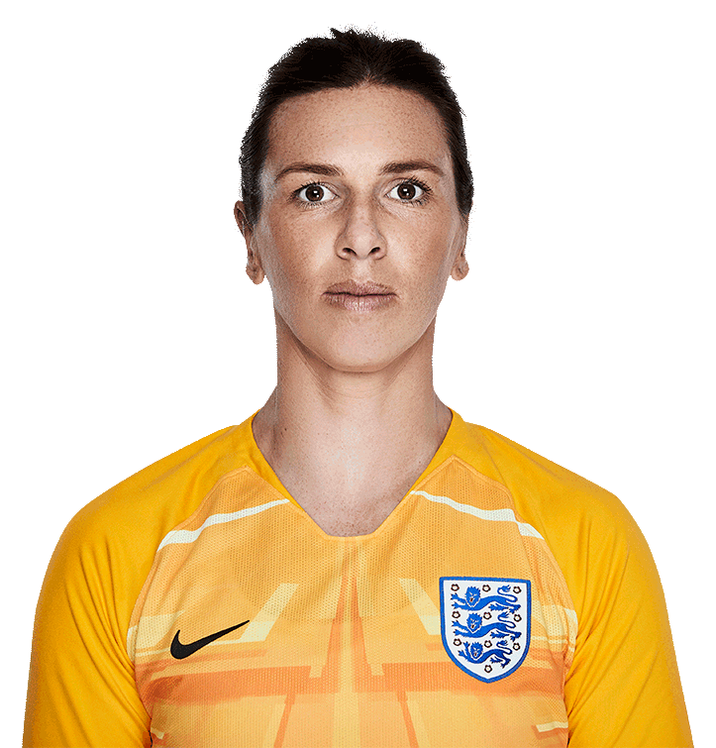 | 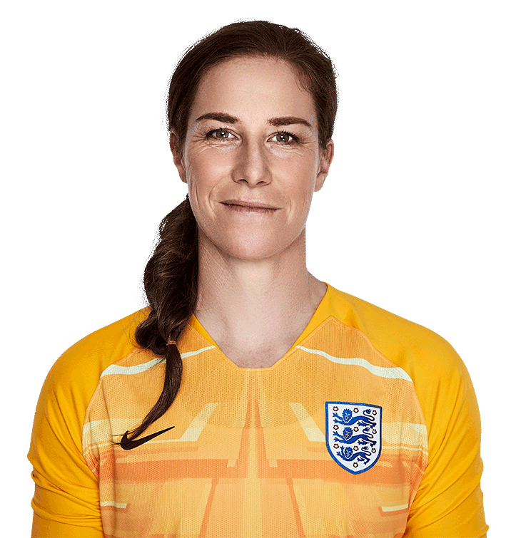
Try to throw the ball to one of your wingers to begin an attack. | Try to start a counter attack at speed having caught the ball.

Mary Earps - Goalkeeper | Abbie McManus - Defender
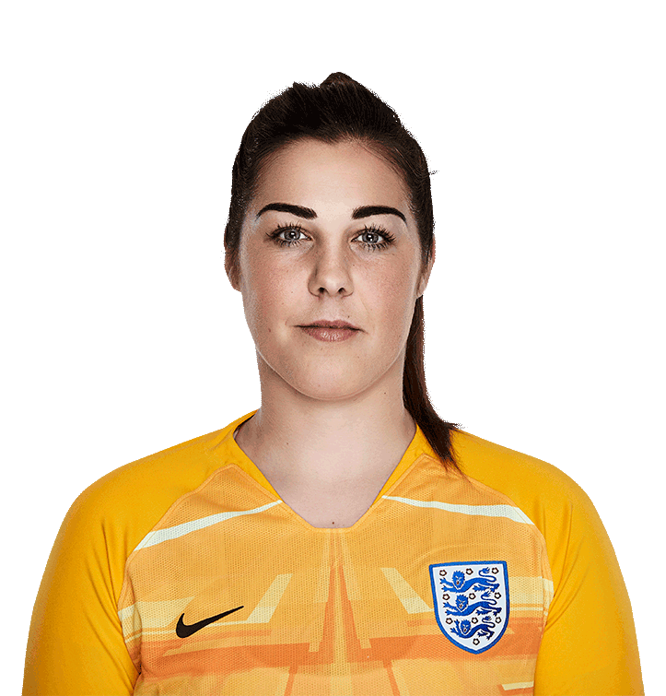
Try to make 5 or more saves by catching the ball. | Try to pass the ball forwards as often as possible.

Alex Greenwood - Defender | Demi Stokes - Defender
Try to win the ball then play a forward pass into a wide position. | Try to combine with a player to create an overlap.

Leah Williamson - Defender | Lucy Bronze - Defender
Try to win 5 tackles or more during the match. | Try to break down corner kicks and crosses as quickly as possible.

Millie Bright - Defender | Rachel Daly - Defender
Try to receive the ball from your goalkeeper at least 3 times in the match. | Try to make forward passes to 3 different players during the match.

Steph Houghton - Defender | Georgia Stanway - Midfield
Try to make 5 accurate passes to a team mate during the match. | Try to use 3 different moves to beat players during the match.

Jade Moore - Midfield | Jill Scott - Midfield
Try to makes tackles and win the ball in the middle part of the pitch. | Try to make 5 accurate passes to at least 3 different team mates during the match.

Karen Carney - Midfield | Keira Walsh - Midfield
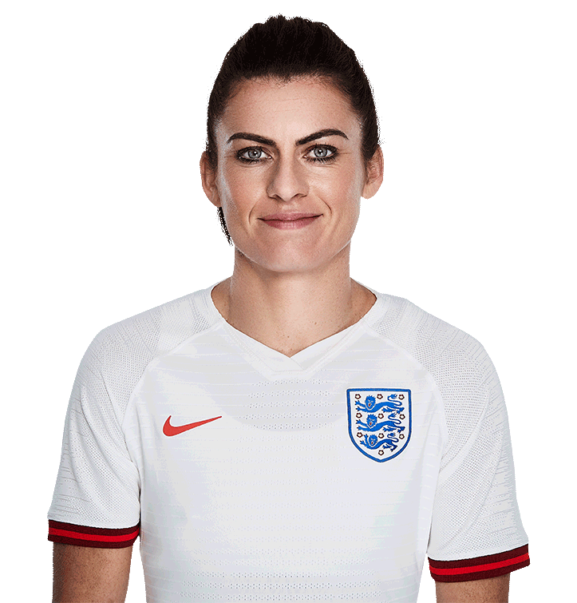
Try to receive the ball from a defender and start attacks as often as possible. | Try to beat opposition players by pushing the ball past them and running onto it.

Lucy Staniforth - Midfield | Beth Mead - Attack
Try to make 3 or more one touch passes during the match. | Try to receive the ball with one foot and shoot with the other foot.

Ellen White - Attack | Fran Kirby - Attack
 | 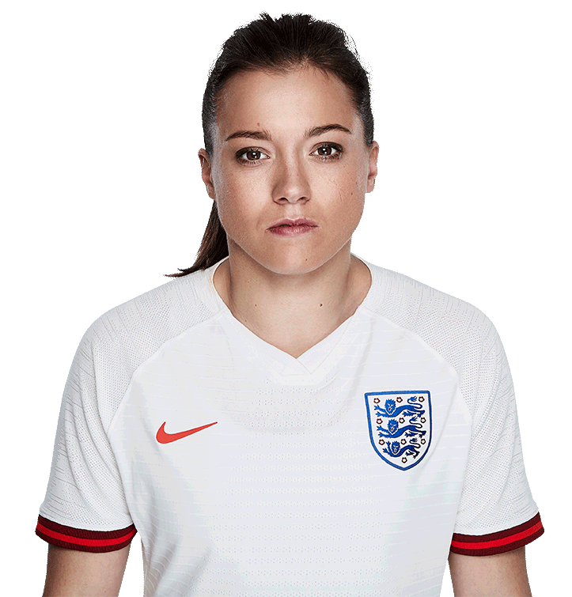
Try to break into the penalty area at speed and shoot across the goalkeeper. | Try to be as exciting as you can with the ball to create a goalscoring opportunity.

Jodie Taylor - Attack | Nikita Parris - Attack
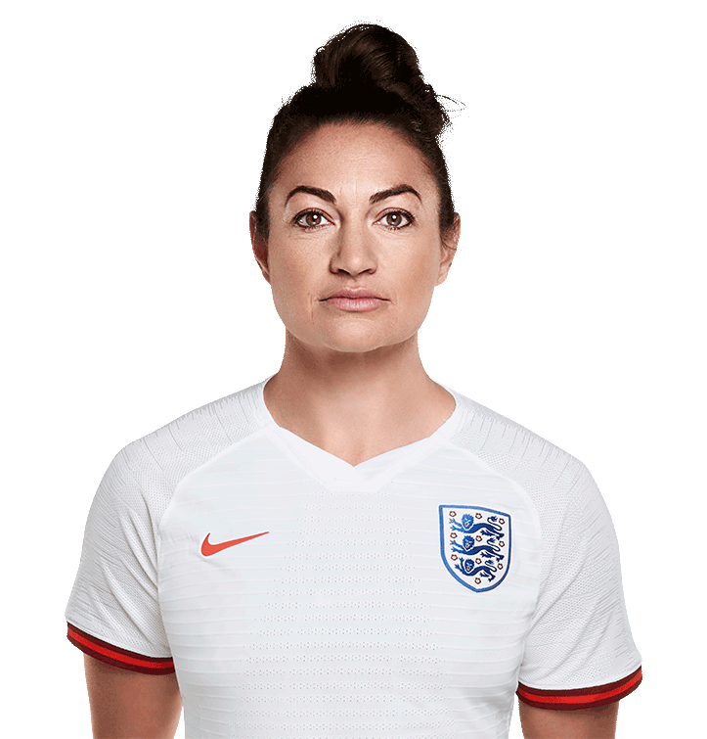 | 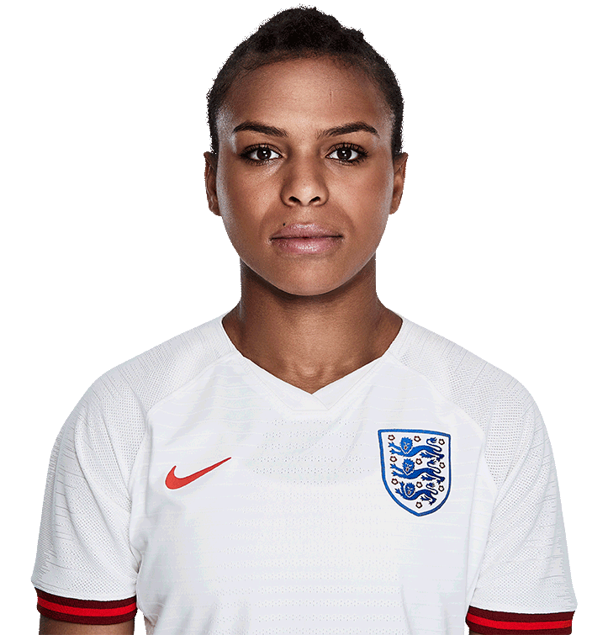
Try to have a shot from outside of the penalty area. | Try to beat an opponent by knocking the ball past them and winning the race.

Toni Duggan - Attack
Try to score a goal with a first time shot.

Horsforth St Margaret’s  Hurricanes – Under 11s | Horsforth St Margaret’s  Hurricanes – Under 11s

