Horsforth St Margaret’s JFC Medical Consent Form

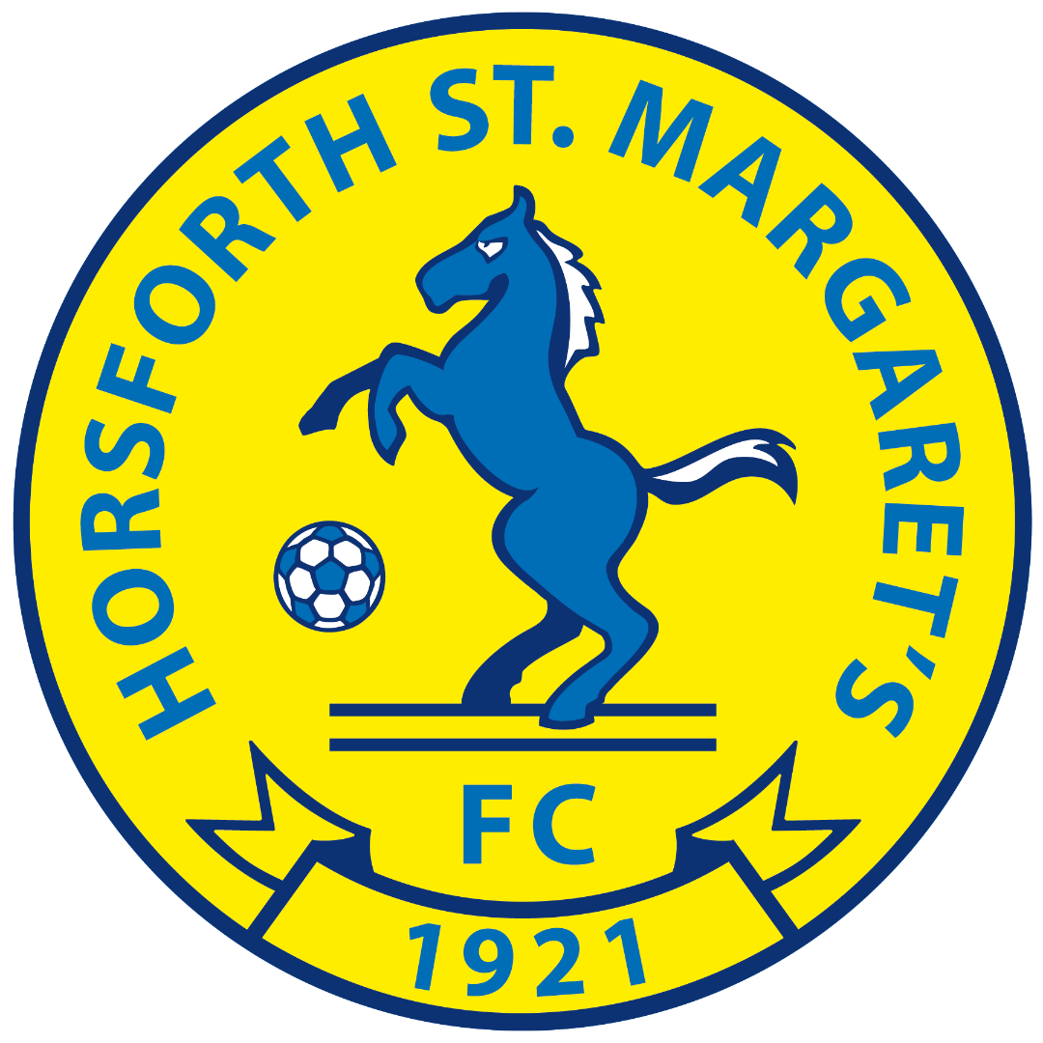

Status (Please tick) | Mr |  | Mrs |  | Ms |  | Other

Child’s First Name: |  | Child’s Surname:
Emergency  Telephone No. 1: |  | Emergency  Telephone No. 2:
Child’s Date of Birth:

Parental Email Address:

Medical Conditions or Allergies
Parental Consent:
In the event that my daughter is injured whilst playing football/travelling to and from football events and I cannot be contacted on the above number, I hereby give my consent for my child to receive medical attention.

Signed:

Print Name:

Date:

In the event that the above named person cannot be reached, please give two extra emergency contact names and numbers.

Name: | Emergency Contact Number:
Name: | Emergency Contact Number:

